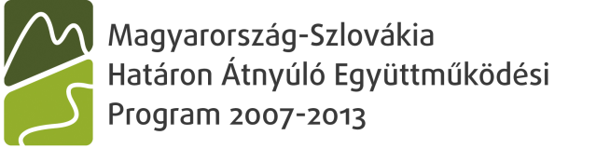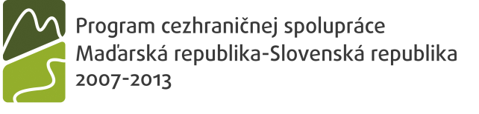


www.husk-cbc.eu – HUSK/1001/1.1.2/0022

Project title: Hunting and forestry cluster to promote sustainable cross-border development/ Erdészeti és Vadászati klaszter a határon átnyúló fenntartható fejlődés elősegítésére / Lesnícky a poľovnícky klaster pre napomáhanie udržateľného rozvoja cezhraničnej spolupráce.

Shortened project title: Hunting and forestry cluster/Vadászati és Erdészeti Klaszter / Poľovnícky a lesnícky klaster.

Project code: HUSK/1001/1.1.2/0022

The project called Hunting and forestry cluster to promote sustainable cross-border development was approved for funding on June 8, 2011 from Joint Monitoring Commitee for Cross-border Cooperation Programme Hungary – Slovak Republic.

Partners: Ipoly Erdő Zrt. (Ipoly Forests OJSC) is lead partner of the project. Another Hungarian project partner is Nógrád Megyei Kereskedelmi és Iparkamara (Chamber of Commerce and Industry of Nográd district). Slovak project partners: Regionálna rozvojová agentúra pre rozvoj regiónu Stredného Poiplia (Regional development agency in region of Stredné Poiplie) in Veľký Krtíš, and Národné lesnícke centrum (National Forest Centre) in Zvolen. Slovak state forest enterprise – Lesy SR, š.p. (Forests of the Slovak Republic) in Banská Bystrica is involved in the project as a partner without financial support.
Total project budget has been planned at 367.074 EUR, of which 300.100 EUR should be covered from ERDF sources and 48.620 EUR from national governments. Own contribution is 5% of the project budget, which makes 18.354 EUR.
Project started on February 1, 2012, and implementation of project tasks is planned for two years.

Project objective: setting new trade, consultancy and information cluster with market survey, information and marketing services and tools. A specific project objective is to improve conditions for entrepreneurs active in forestry, hunting and tourism through creation the cluster that will enhance development of cross-border business contacts.

Project target group: direct target group of the project should be members of the cluster created (approximately 300 members at both, Slovak and Hungarian, sides of the border): private as well as state forest managers, forest owners, hunting organisations and sellers of hunting products, owners of hunting houses offering accommodation for hunters, pensions providing general tourism services with potential for eco-tourism development, and “schools in nature”.

Advantages for members joining the cluster: the cluster members will have access to cluster database, they can gain contact details of their possible partners, their activities as well as free capacities. This allows active economical cooperation among the members and more efficient use of their resources. Marketing studies will be produced within the project implementation (three studies in Hungarian language and three in Slovak language). The studies will cover following themes: biomass as forest product and renewable energy source, hunting and game management, and eco-tourism. Common use of these studies and knowledge create new forms of cooperation, opportunities and markets supporting sustainable development. The project partners agreed to provide cluster members with information material. All information material will be available at internet site. However members who do not have access to internet (or do have limited internet access) must be informed through hardcopies of studies and information publications – list of cluster members with their contact details.

Project partners will focus with emphasis on public awareness, permanent information activities and availability of the project products for all.

Sources of financing

Project partner | Maximum contribution from ERDF  EUR | Funding rate from ERDF  % | Maximum national funding  EUR | National funding rate  %* | Total budget  EUR  (including own contribution)
LP - Ipoly Erdő Zrt.: Ipoly Erdő Zártkörűen Működő Részvénytársaság  (Ipoly Forests OJSC) | 100,460.39 | 80.75 | 17,728.30 | 14.25 | 124,409.16
CBP - RRA Stredné Poiplie: Regionálna rozvojová agentúra pre rozvoj regiónu Stredného Poiplia  (Regional development agency in region of Stredné Poiplie) | 39,747.97 | 80.75 | 7,014.34 | 14.25 | 49,223.50
PP - NKIK: Nógrád Megyei Kereskedelmi és Iparkamara  (Chamber of Commerce and Industry of Nográd district) | 86,141.82 | 80.75 | 15,201.49 | 14.25 | 106,677.19
PP - NLC: Národné lesnícke centrum  (National Forest Centre) | 73,749.56 | 85.00 | 8,676.42 | 10.00 | 86,764.19
Total: | 300,099.74 |  | 48,620.55 |  | 367,074.04

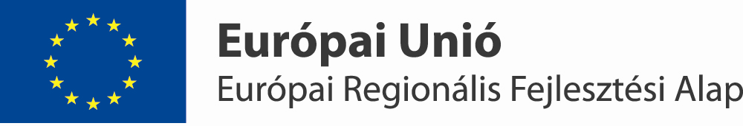
A projekt az EU társfinanszírozásával, a Magyarország-Szlovákia Határon Átnyúló Együttműködési Program 2007-2013 keretében valósul meg.
Projekt sa realizuje v rámci Programu cezhraničnej spolupráce Maďarsko – Slovenská republika 2007 – 2013
spolufinancovaný z ERDF
